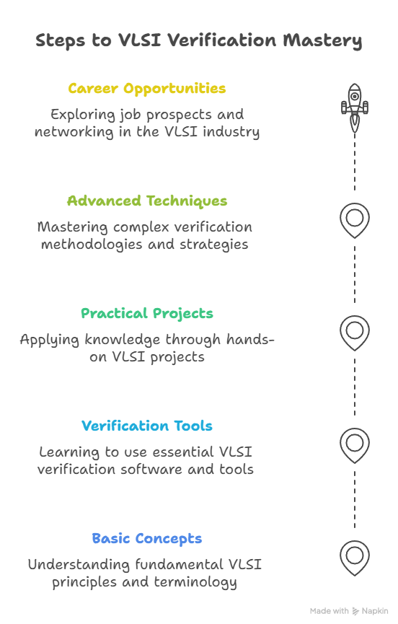

If you're pursuing a degree in ECE or EEE and are interested in entering the world of chip design, VLSI Verification is one of the most promising career paths you can explore. With the right planning and focused efforts, you can become industry-ready even before you graduate.
This guide is crafted to help you understand what it takes, what to learn, and how to prepare efficiently.
🔍 Understanding the Role of a VLSI Verification Engineer
A verification engineer ensures that the digital designs of a chip behave as expected before fabrication. They write test environments and simulate chip functionality to identify errors early in the design process. It's a role that blends coding, digital logic, and analytical problem-solving.
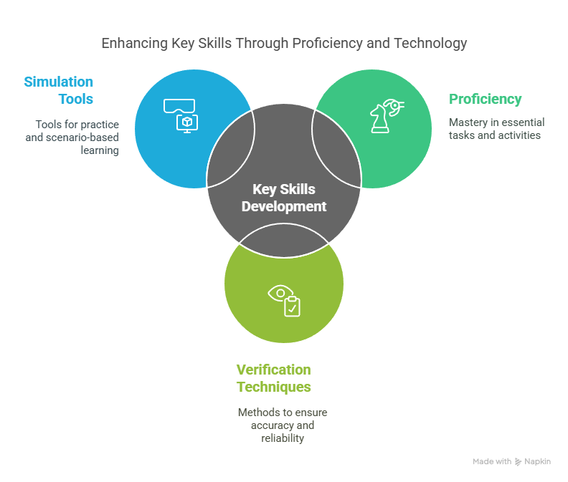
📚 Step 1: Strengthen Your Fundamentals
Start with these building blocks:
- Digital Electronics: Understand combinational and sequential logic
- Verilog HDL: Begin with simple modules and simulations
- Basic Programming: Learn C or Python for scripting
- Data Structures: Understand queues, arrays, and linked lists for testbench design
🛠️ Step 2: Develop Key Skills
🔹 HDL Proficiency
- Begin with Verilog; once comfortable, move to SystemVerilog
- Practice writing testbenches and simulate regularly
🔹 Verification Techniques
- Learn about UVM (Universal Verification Methodology)
- Understand concepts like constrained random testing, functional coverage, and assertions
🔹 Tools & Simulators
- Use open-source tools like Icarus Verilog, GTKWave, Verilator
- Learn to compile, simulate, and debug code efficiently
🔹 Scripting Skills
- Get comfortable with Python, TCL, or basic shell scripting
- Automate testbenches and regression tests
🔹 Communication & Documentation
- Clearly document your projects and verification reports
- Sharpen your communication for team collaborations and interviews
⌛ Step 3: Smart Learning Strategy
Rather than diving into everything, follow a structured and focused approach:
- 📅 Mini Projects: Create simple digital modules like counters, ALUs, etc.
- 📅 Online Resources: Use NPTEL, Udemy, YouTube tutorials
- 📅 Open Source Practice: Work with free tools to simulate designs
- 📅 GitHub Portfolio: Document and share your work for visibility
- 📅 Networking: Join LinkedIn communities and forums for updates and guidance

